Borehole No. GM70
Location Issac, Afram Plains
Latitude N 07°03.242’
Longitude W000°35.169’
Date started --/01/2000
Date completed 14/01/2000
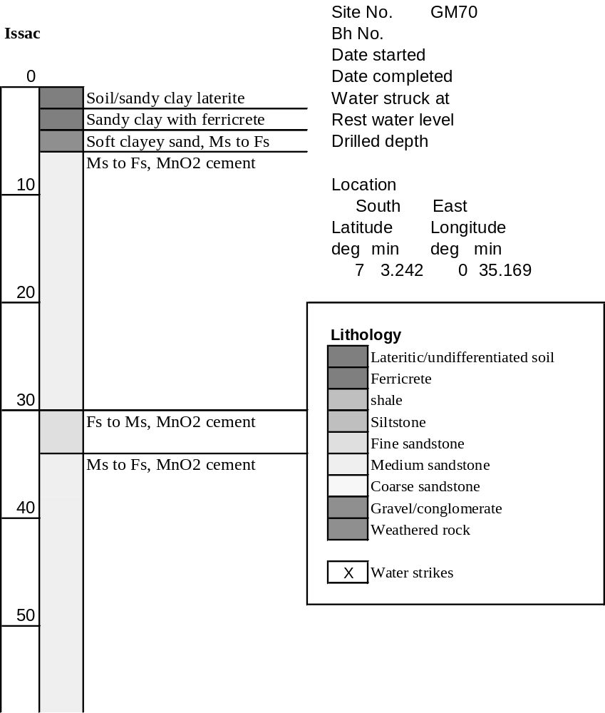

Summary Lithological Log
Depth(m)
From To
0 1 Soil/sandy clay/laterite
1 3 Sandy clay with ferricrete
3 5.1 Soft weathered clayey sand and medium to fine sandstone
5.1 30.5 Medium to fine sandstone with manganese cement
30.5 33.5 Fine to medium sandstone with manganese cement
33.5 58.9 Medium to fine sandstone with manganese cement

Detailed Lithological Log
Depth(m) Lithology
From To

Soil/sandy clay/laterite
0 1 Red orange and light brownish grey sandy clay

Sandy clay and ferrecrete
1 2 Yellow/grey and light brown/grey sandy clay with rounded yellow to
brown silcretised ferricrete nodules
2 3 Light grey/green sandy clay with red orange partings and yellow
orange ferricrete nodules

Soft weathered clayey sand and medium to fine sandstone
3 4.1 Red/grey to light brown/grey clayey sand with bright orange/ochre
partings
4.1 5.1 Fairly soft dark brown ferruginous medium to fine grained sandstone
with some pink grains and some black MnO cement

Medium to fine sandstone with manganese cement
5.1 6.1 Dark black/brown ferruginous medium to fine grained sandstone with
some pink grains and much black MnO cement
6.1 7.1 Dark red/brown and black medium to fine grained
sandstone,ferruginous with many pink fragmented grains and black
MnO cement
7.1 8.1 Dark red/brown and black medium to fine grained sandstone,
ferruginous with many pink fragmented grains and black MnO cement
8.1 9.1 Dark red/brown and black medium to fine grained sandstone,
ferruginous with many pink fragmented grains and black MnO cement;
subordinate very hard fine grained black to black/brown
manganiferous sandstone
9.1 10.2 Dark red/brown medium to fine grained sandstone, fairly soft with
many pink/orange grains and some black MnO cement
10.2 11.2 Dark brown/black ferruginous medium to fine grained sandstone with
black MnO cement; subordinate light orange and grey medium grained
sandstone
11.2 12.2 Dark red/brown medium to fine grained sandstone with many pink
grains and some black MnO cement, fairly soft with platy fragments
12.2 13.2 Dark red/brown ferruginous medium to fine grained sandstone with
many pink grains and some black MnO cement; subordinate light
orange and grey medium sandstone with no MnO cement
13.2 14.2 Dark brown/black ferruginous medium to fine grained sandstone with
few pink grains but much black MnO cement
14.2 15.2 Dark red/brown fairly soft medium to fine grained sandstone, some
pink grains and black MnO cement; subordinate hard orange and grey
medium grained sandstone with no MnO cement
15.2 16.3 Dark red/brown medium to fine sandstone, pink grains and black MnO
cement; subordinate dark red hard sandy siltstone with black mica;
grey and orange hard medium sandstone - no MnO; and black/brown
fine grained manganiferous sandstone
16.3 17.3 Dark red/brown medium to fine grained fairly soft ferruginous
sandstone, some pink grains and black MnO cement
17.3 18.3 Dark red/brown medium to fine grained ferruginous sandstone with
some pink grains and black MnO cement; subordinate orange/brown
medium grained sandstone with some black MnO cement
18.3 19.3 Dark brown/black medium to fine grained ferruginous sandstone with
some pink grains and black MnO cement
19.3 20.3 Dark brown medium to fine grained sandstone with pink grains and
black MnO cement; subordinate hard orange and grey medium grained
sandstone - no MnO cement
20.3 21.3 Dark brown medium to fine fairly soft sandstone, some orange grains
and black MnO cement; subordinate hard brown/black fine
manganiferous sandstones; orange and grey hard medium sandstone –
no MnO; and grey fine sandstone with mica
21.3 22.4 Dark brown medium to fine hard sandstone, some pink/orange grains
and black MnO cement; subordinate light grey and orange hard
medium sandstone - no MnO cement
22.4 23.4 Dark brown medium to fine grained sandstone, some orange/pink
grains and black MnO cement; some light blue/grey siltstone and grey
and orange medium sandstone
23.4 24.4 Dark red/brown ferruginous medium to fine sandstone with
orange/pink grains and some black MnO cement
24.4 25.4 Dark brown ferruginous medium to fine grained sandstone with pink
grains and black MnO cement; subordinate light orange and grey
medium sandstone with interbedded light blue/grey mudstone
25.4 26.4 Dark brown medium to fine grained sandstone with pink grains and
black MnO cement
26.4 27.4 Dark red/brown medium to fine grained ferruginous sandstone with
many orange/pink grains and some black MnO cement
27.4 28.4 Dark brown ferruginous medium to fine grained sandstone with
orange/pink grains and black MnO cement
28.4 29.5 Dark brown/black medium to fine grained sandstone with some
orange/pink grains and much black MnO cement
29.5 30.5 Dark brown/black medium to fine grained sandstone with some
orange/pink grains and much black MnO cement

Fine to medium sandstone with manganese cement
30.5 31.5 Dark brown/black fine to medium grained sandstone, ferruginous and
manganiferous
31.5 32.5 Dark orange/brown to brown/black medium to fine grained sandstone
with pink/orange grains and black MnO cement; subordinate light
orange and grey medium sandstone with no MnO cement
32.5 33.5 Dark red/brown fine to medium grained sandstone with much MnO
cement, some mica like
Medium to fine sandstone with manganese cement
33.5 34.5 Red/brown to black medium to fine grained sandstone, some
orange/pink grains and black MnO cement
34.5 35.6 Dark orange/brown medium to fine grained sandstone, some orange
grains and black MnO cement
35.6 36.6 Dark orange/brown medium to fine grained sandstone with
pink/orange grains and black MnO cement; subordinate dark
brown/black manganiferous hard fine grained sandstone
36.6 37.6 Dark orange/brown medium to fine grained sandstone, some orange
grains and black MnO cement
37.6 38.6 Dark orange/brown medium to fine grained sandstone with
orange/pink grains and black MnO cement; subordinate very hard fine
grained brown/black manganiferous sandstone
38.6 39.6 Dark brown ferruginous medium to fine grained sandstone with orange
grains and black MnO cement
39.6 40.6 Dark brown ferruginous medium to fine grained fairly soft sandstone
with orange grains and black MnO cement; subordinate orange and
light grey medium sandstone with no black MnO cement
40.6 41.7 Dark red/brown ferruginous medium to fine grained sandstone with
some black MnO cement on bedding planes
41.7 42.7 Dark red/brown ferruginous medium to fine grained sandstone with
some black MnO cement and mica like deposits on bedding surfaces
42.7 43.7 Dark red/brown medium to fine ferruginous sandstone with orange
fragmented grains and some black MnO cement on bedding planes;
subordinate orange and grey medium sandstone, no MnO
43.7 44.7 Dark orange/brown medium to fine grained sandstone with many
fragmented orange grains and some black MnO cement
44.7 45.7 Dark brown ferruginous medium to fine grained fairly soft sandstone
45.7 46.7 Dark orange/brown to dark brown ferruginous medium to fine
sandstone, with orange fragmented grains and some black MnO
cement along bedding planes
46.7 47.8 Dark orange/brown to dark brown ferruginous medium to fine
sandstone, with orange fragmented grains and some black MnO
cement along bedding planes; subordinate grey and orange medium
sandstone - no MnO cement
47.8 48.8 Dark red/brown to dark brown ferruginous medium to fine grained
sandstone with some fragmented orange grains and black MnO cement
the latter especially with fine grained sandstone layers
48.8 49.8 Dark orange/brown medium to fine grained sandstone with fragmented
orange grains and black MnO cement along bedding planes
49.8 50.8 Dark orange/brown ferruginous medium to fine grained sandstone,
with fragmented orange grains and black MnO cement,the latter
increased in fine grained sandstone layers
50.8 51.8 Dark orange/brown to dark brown ferruginous medium to fine grained
sandstone with fragmented orange grains and some black MnO cement
- hard in parts
51.8 52.8 Dark orange/brown ferruginous medium to fine grained sandstone with
fragmented orange grains and a little black MnO cement
52.8 53.8 Dark orange/brown ferruginous medium to fine grained sandstone with
fragmented orange grains and a little black MnO cement
53.8 54.9 Dark orange/brown to brown/black medium to fine grained sandstone,
some fragmented orange grains and black MnO cement
54.9 55.9 Dark orange/brown medium to fine grained sandstone with fragmented
orange grains; subordinate black/brown manganiferous fine grained
sandstone
55.9 56.9 Dark orange/brown medium to fine grained sandstone with fragmented
orange grains and some black MnO cement along bedding planes
56.9 57.9 Dark orange/brown medium to fine grained sandstone with fragmented
orange grains and some black MnO cement along bedding planes
57.9 58.9 Dark orange/brown medium to fine grained sandstone with fragmented
orange grains and some black MnO cement along bedding planes

